**Loan Approval Prediction**

**1. Introduction and Problem Definition**

The financial industry, particularly banking, traditionally, loan approval decisions were made manually by bank officers based on factors such as credit history, income, employment status, and financial liabilities. However, with the advent of machine learning (ML) and data analytics, this process has become more automated and data-driven. Predicting loan approval is now a well-established problem in the field of machine learning, with various algorithms and techniques used to predict whether a loan application will be accepted or rejected.

The primary objective of loan approval prediction is to develop an automated system that can accurately assess whether a loan should be granted. This automation minimizes the manual effort involved, reduces human bias, and speeds up the decision-making process. Moreover, it allows banks to minimize risks by identifying potential defaults before issuing loans.

**Problem Statement**

Given a dataset of loan applications with multiple features (including applicant income, credit history, loan amount, etc.), we aim to build a machine learning model that predicts whether a loan will be approved (Y) or denied (N). The model should optimize accuracy, ensuring that both approval and rejection are predicted.

The challenge involves working with both structured numerical and categorical data, preprocessing missing values, and selecting the right model. Moreover, loan data often exhibit imbalances, where most loans may be approved, resulting in biased models if not handled correctly.

Goals and Objectives

The project aims to achieve the following:

* Develop a reliable predictive model to classify loan applications as either approved or denied.
* Explore various machine learning algorithms, optimizing for accuracy and robustness.
* Address data imbalances using appropriate techniques.

**2. Data Analysis :**

* Data analysis is crucial for understanding the dataset and uncovering hidden patterns, trends, and correlations that can inform model-building decisions. Loan datasets typically consist of a combination of numerical and categorical features, each playing a distinct role in determining the outcome (loan approval or denial).

**Features of Loan Application status Dataset**

A typical dataset for loan approval prediction might contain the following features:

1. Loan_ID - This refer to the unique identifier of the applicant's affirmed purchases

2. Gender - This refers to either of the two main categories (male and female) into which applicants are divided on the basis of their reproductive functions

3. Married - This refers to applicant being in a state of matrimony

4. Dependents - This refres to persons who depends on the applicants for survival

5. Education - This refers to number of years in which applicant received systematic instruction, especially at a school or university

6. Self_Employed - This refers to applicant working for oneself as a freelancer or the owner of a business rather than for an employer

7. Applicant Income - This refers to disposable income available for the applicant's use under State law.

8. CoapplicantIncome - This refers to disposable income available for the people that participate in the loan application process alongside the main applicant use under State law.

9. Loan_Amount - This refers to the amount of money an applicant owe at any given time.

10. Loan_Amount_Term - This refers to the duaration in which the loan is availed to the applicant

11. Credit History - This refers to a record of applicant's ability to repay debts and demonstrated responsibility in repaying them.

12. Property_Area - This refers to the total area within the boundaries of the property as set out in Schedule.

13. Loan_Status - This refres to whether applicant is eligible to be availed the Loan requested.

**Initial Data Exploration**

**Missing Values**

One of the first steps in data analysis is to handle missing values. Features such as Gender, Married, Dependents, Self_Employed, LoanAmount, Loan_Amount_Term ,Credit_History contain missing value so dealing with missing values is essential to avoid introducing biases or incorrect model behavior.

Distribution of Numerical Features,

**Applicant Income**: Applicant incomes are typically right skewed, with most applicants falling within a moderate range and a few earning very high incomes.

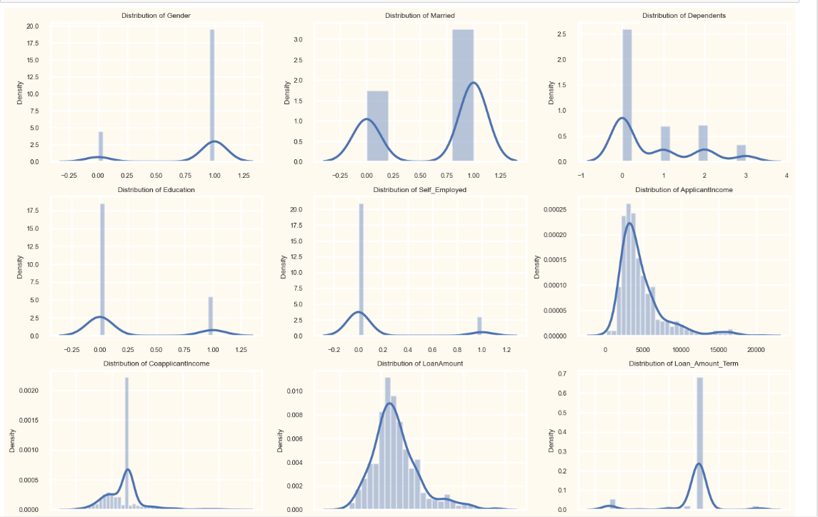

**Loan Amount**: The loan amount usually follows a bell curve, with a concentration around moderate values. Large loan requests are less frequent.

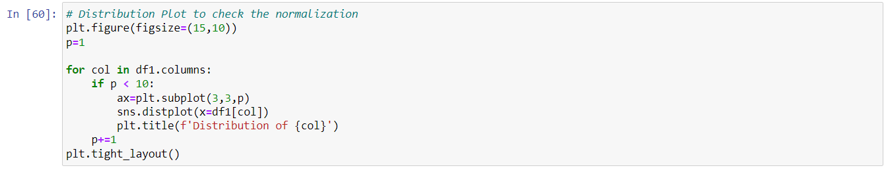

**3. Exploratory Data Analysis(EDA) :**

Exploratory Data Analysis (EDA) aims to understand the relationships between features and the target variable (Loan_Status). This process not only provides insights but also helps identify which variables are the most important predictors of loan approval.

Key Insights from EDA,

1. **Gender vs Income :** Higher applicant incomes generally correlate with male person, increased loan approval chances. However, income alone does not guarantee approval; married and other factors significantly influence the outcome.

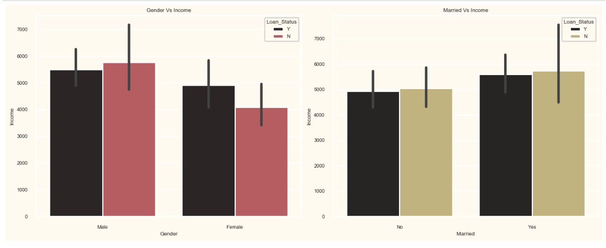

1. **Credit vs Loan Status :** Higher credit scores generally correlate with male person, increased loan approval chances.

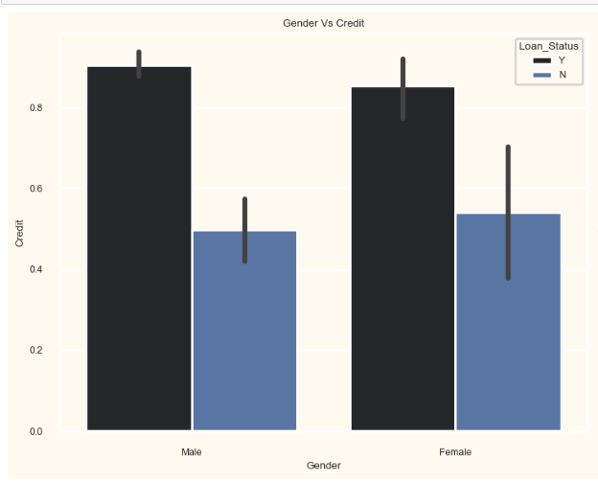

3. **Married vs Gender w.r.t Loan status :** This plot shows, married male applicants have higher loan approval rates as compared to unmarried applicants and married men are more likely to get approval for a loan.So we can conclude that, the marital status has an impact on loan approval.

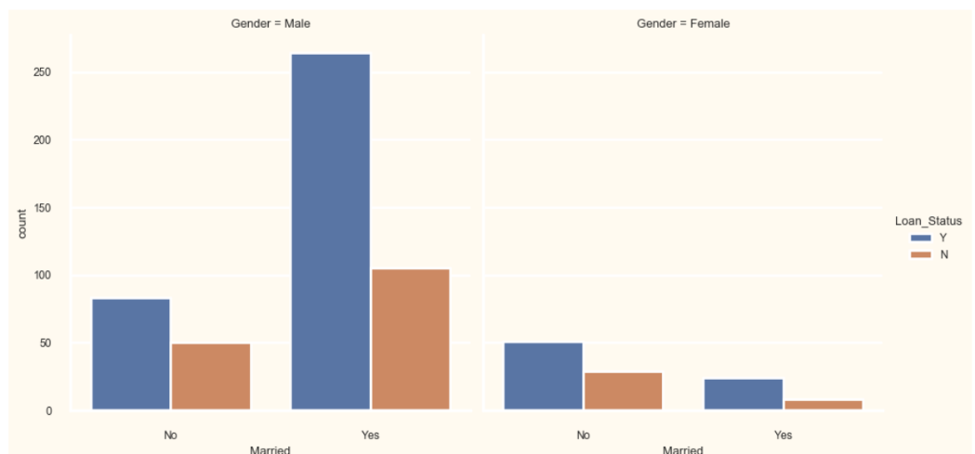

4. **Education vs Gender w.r.t Loan status :** Graduate male applicants have higher loan approval rates as compared to under graduates male as well as graduate and under graduates female applicants and Highly educated male applicants are more likely to get approval for a loan.So we can conclude that, the education status has an impact on loan approval.

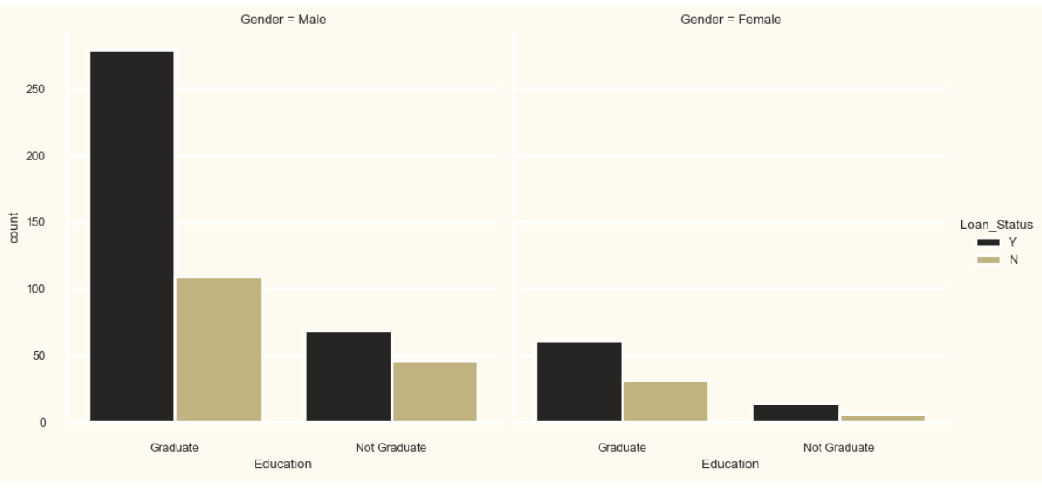

5. **Self-employed vs Gender w.r.t Loan status :** non self-employed male applicants have higher loan approval rates as compared to self-employed male as well as self-employed and non self-employed female applicants and salaried-employed male applicants are more likely to get approval for a loan.So we can conclude that, the employment status has an impact on loan approval.

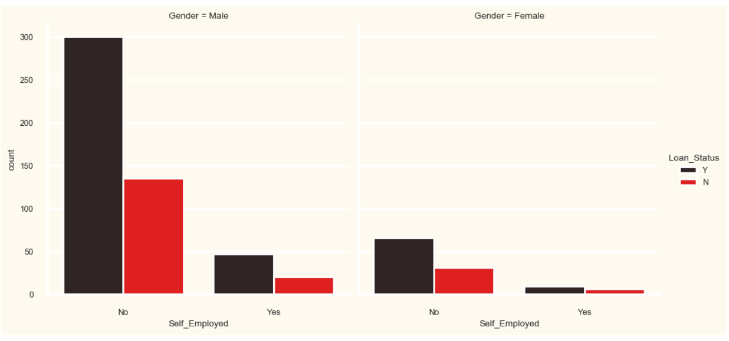

6. **Dependents vs Gender w.r.t Loan status** : the applicant with more dependents tend to have lower approval rates and Male applicants with no dependents are more likely to be approved for a loan.

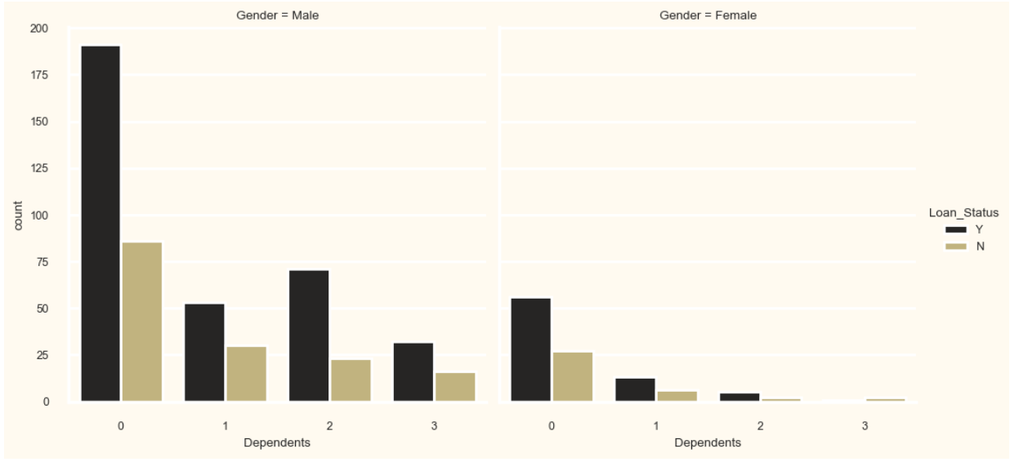

In summary, EDA concludes that credit history, applicant income, and dependents are the strongest individual predictors of loan approval. These insights provide a foundation for building the machine learning models.

**4. Pre-processing pipeline :**

Preprocessing the data is essential to prepare it for machine learning. In this step, we clean the data, handle missing values, encode categorical variables, scale numerical features, and balance the dataset if our given dataset are imbalanced. Let’s break down the steps:

1. Handling Missing Values :

Missing values can introduce bias or reduce the efficiency of the model.In our dataset:

**LoanAmount and Loan_Amount_Term**: Missing values can be imputed using the median or mean of the respective columns.

**Credit_History**: Since this is a critical predictor, missing values may need to be handled more carefully. We could impute them based on correlations with other variables, or drop records with missing values.

**Dependents and Self_Employed**: Missing values in these categorical fields can be filled using mode imputation (the most frequent value).

1. Encode Categorical Feature :

Machine learning algorithms typically require numerical input, so categorical variables must be encoded into a numerical format :

**Binary Variables** (Gender, Married, Self_Employed): Can be encoded as 0 and 1 (Male = 1, Female = 0 like that only).

**Multi-Class Variables** (Property_Area, Education): These variables can be transformed using Ordinal Encoding.

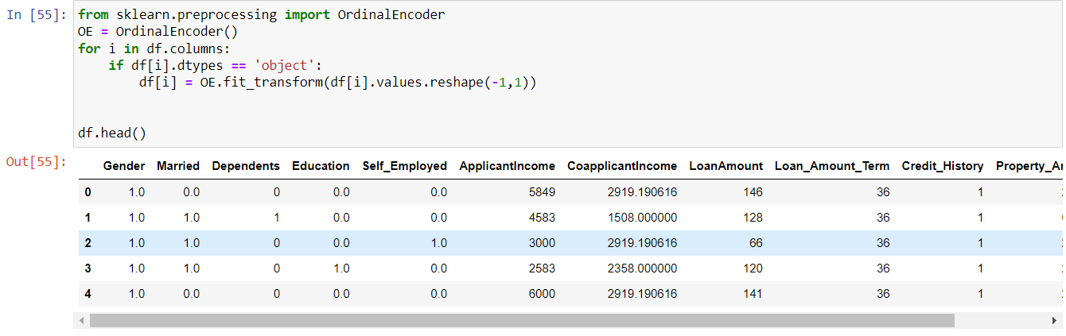

1. Feature Scaling :

Numerical features such as ApplicantIncome and LoanAmount can have wide ranges. Some machine learning models, are sensitive to feature scales. Standardization (scaling the data to have zero mean and unit variance) or Min-Max scaling (scaling data to fall between 0 and 1) can be applied to these features.

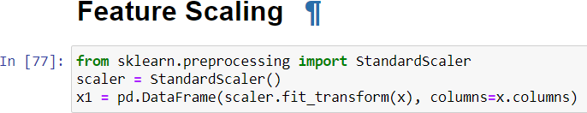

1. Handing Imbalance Dataset :

Loan datasets often exhibit an imbalance between approved and denied loans. This imbalance can skew model performance, causing the model to predict the majority class (loan approvals) more frequently.So we can now apply **SMOTE (Synthetic Minority Over-sampling Technique)**. This method oversamples the minority class by creating synthetic examples based on the existing data.

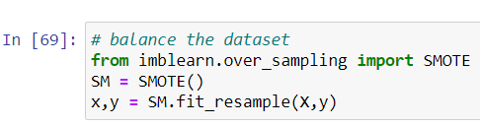

5. Checking the Outlier and Skewness :

Outliers are the abnormal data points that are significantly different from actual data points that form a skewness.Now observe the continuous variabled feature to detect the outlier.If any outliers present then remove that outliers for stable model performance and also remove the skewness of any related data points that are formed normal distribution.

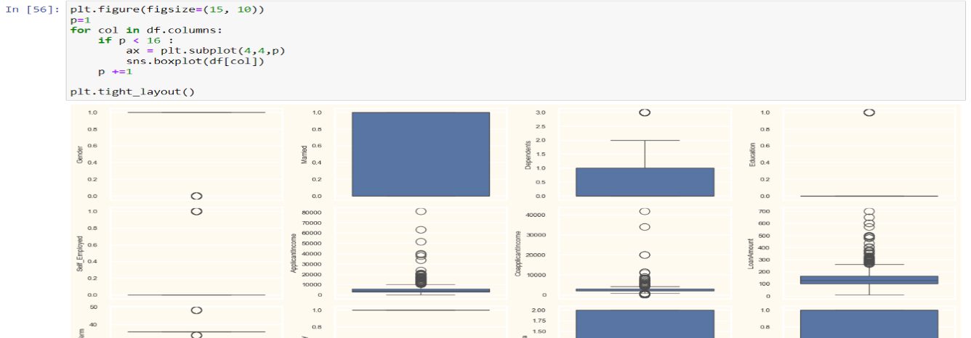

6. Multicolinearity check :

Multicolinearity occurswhen two or more independent variables have high corelations with one another,it affect the bad impact of model performance.So remove the multicolinearity of independent features.

**5. Building Machine Learning Model :**

Now that the data is clean and preprocessed, we can build machine learning models. Several classification algorithms can be applied to predict loan approval.List of the algorithms are used to predict the loan status :

1. **Logistic Regression**:
   * A simple yet powerful classification model that works well when the relationship between the features and the target is mostly linear.
2. **Decision Tree**:
   * A tree-based model that splits the data based on feature values. Each split creates branches, eventually leading to a classification decision at the leaf nodes.
3. **Random Forest**:
   * Random Forest is an ensemble method that builds multiple decision trees using different subsets of data and averages their results to improve accuracy and reduce overfitting.
4. **Gradient Boosting**:
   * Gradient Boosting models build sequential trees, with each new tree correcting the errors of the previous ones.

**Model Evaluation Metrics:**

For this classification task we check which model is best based on below metrics,

* **Accuracy**: Measures the proportion of correct predictions.
* **Precision**: The ratio of correctly predicted positive observations to the total predicted positives.
* **Recall (Sensitivity)**: The ability of the model to capture all actual positives.
* **F1 Score**: The harmonic mean of precision and recall, useful when classes are imbalanced.

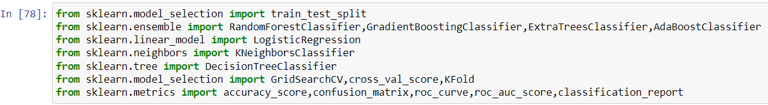

**Now we check which model is perform better and gives the accurate prediction**.

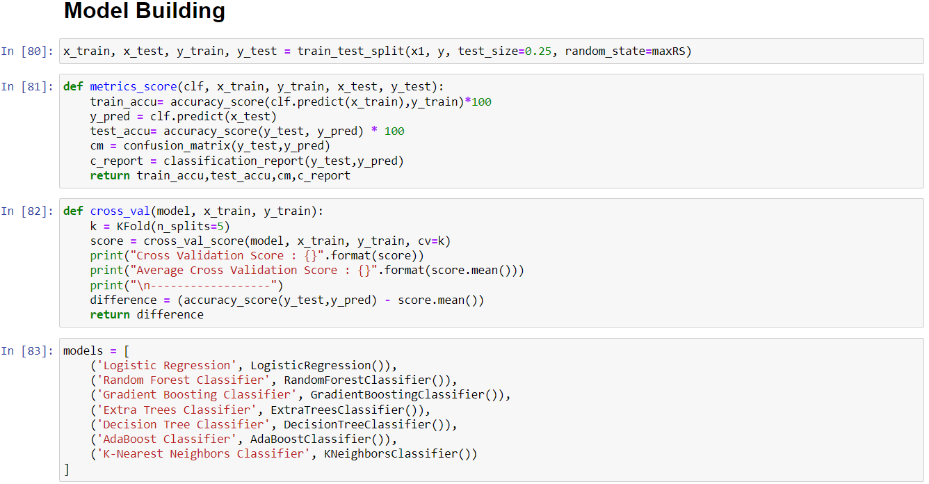

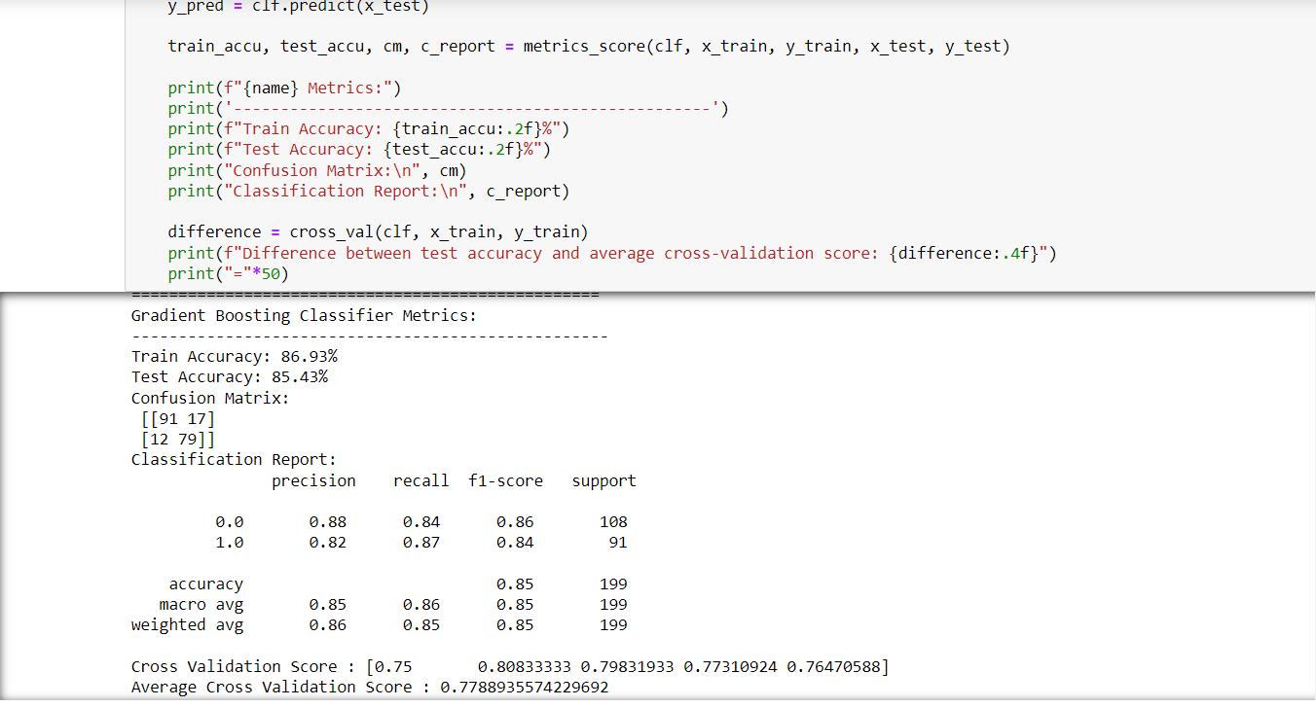

Gradient Boosting Classifier stands out as the best model for the following reasons:

1) The Gradient Boosting achieved a test accuracy of 85.43%, which is the highest among all the models evaluated.

2) Strong Classification Metrics: Precision and Recall: It has very high precision (0.82 for class 1.0) and recall (0.87 for class 1.0), indicating that it performs well in identifying positive cases with minimal false positives and false negatives. F1-Score: The F1-score for class 1.0 is 0.84, demonstrating a good balance between precision and recall.

3) The average cross-validation score of 0.7788 is also high, showing that the model generalizes well across different subsets of the data.

4) Although the training accuracy is 86.93%, the test accuracy remains high at 85.43%, which indicates that the model is not overly complex for the data at hand, minimizing the risk of overfitting.

Hyperparameter Tuning :

Based on the cross validation score we did the model hyperparameter tuning for balance the bias and variance of the selected best model.

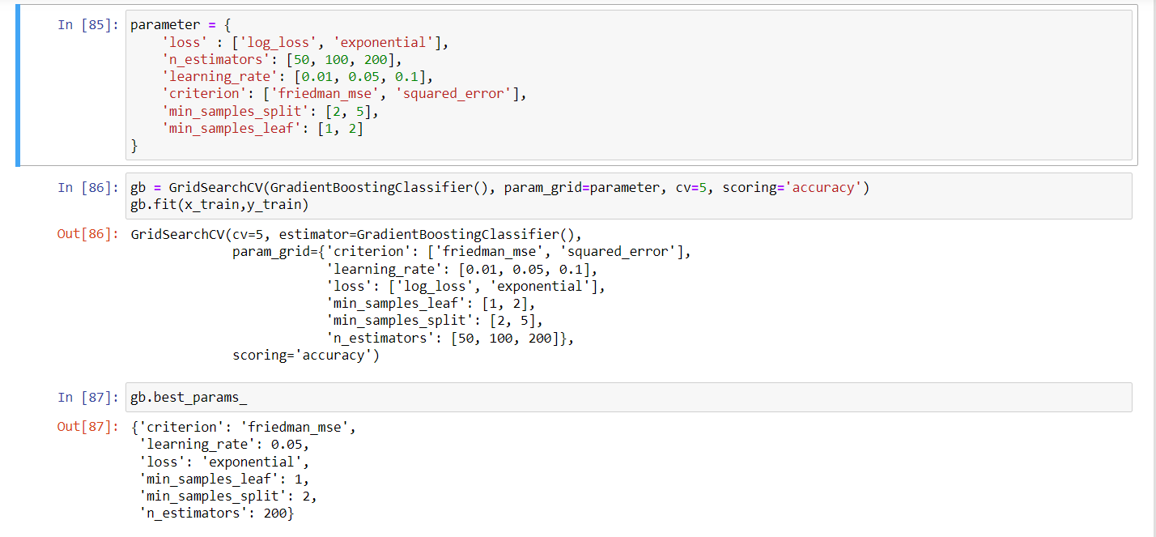

**6. Concluding Remarks :**

In conclusion, loan approval prediction is a critical task in financial services, helping institutions assess the creditworthiness of loan applicants with greater accuracy and efficiency. Through the use of data analysis, exploratory data analysis (EDA), and machine learning models, we can automate this process while minimizing risks.

**Key takeaways:**

1. **Preprocessing is critical**: Cleaning the data, handling missing values, and encoding categorical features is essential for building effective models.
2. **EDA provides valuable insights**: Features like Credit_History, ApplicantIncome, and LoanAmount were found to be strong predictors of loan approval.
3. **Choosing the right model**: While simple models like Logistic Regression offer transparency and ease of implementation, more advanced models like Random Forest and Gradient Boost often perform better in capturing complex patterns.
4. **Addressing imbalanced data**: Techniques like SMOTE and class weighting help ensure that minority classes are not underrepresented in model predictions.

This project demonstrates the value of combining domain knowledge, data science, and machine learning to solve real-world problems. By using these techniques, banks can improve their decision-making process, reduce default rates, and enhance customer experience.

Going forward, further enhancements could involve the inclusion of additional features (such as more granular credit scores or employment stability metrics), model explainability techniques (e.g., SHAP values), and continuous retraining of models with new data to keep them updated with changing market conditions.